484 County Road 113
Carbondale, CO 81623
970 945 7777
Fax – 8389
Ford NP203 Twin Stick Instructions
Instructions for Ford NP203 twin stick shifter
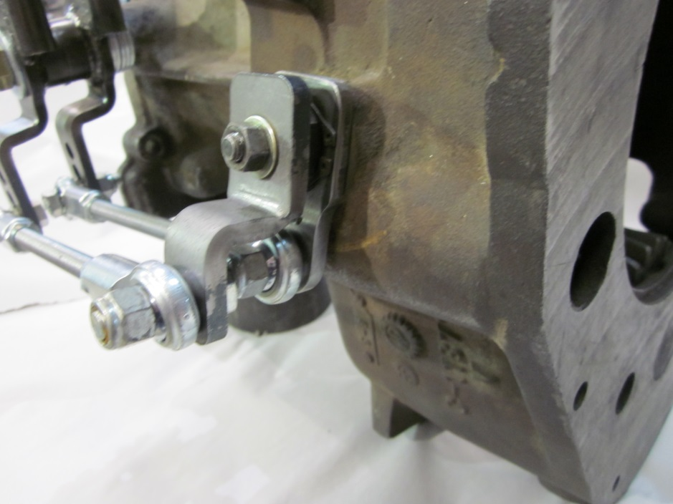
Install spacer between adapter and lever
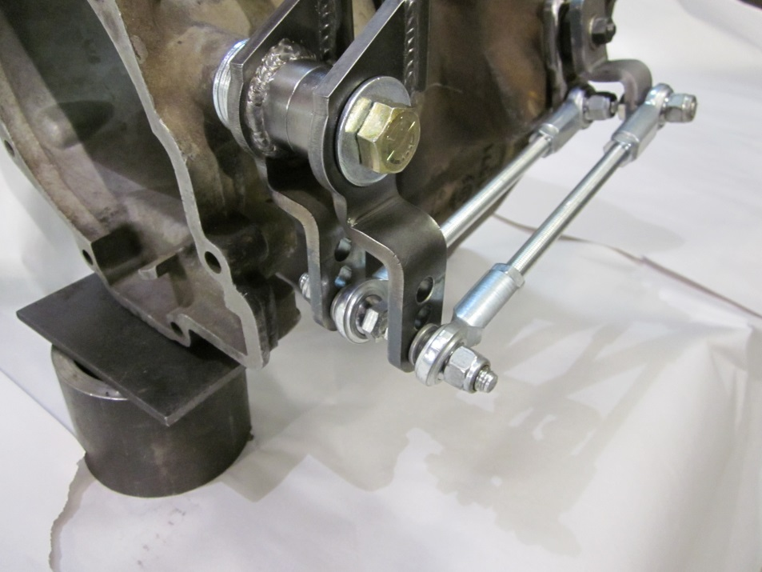
Notice washers between heims and levers

